🧠 Unsupervised Learning – Full Guide
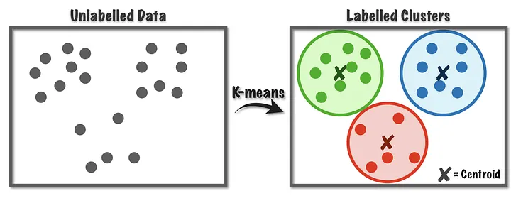

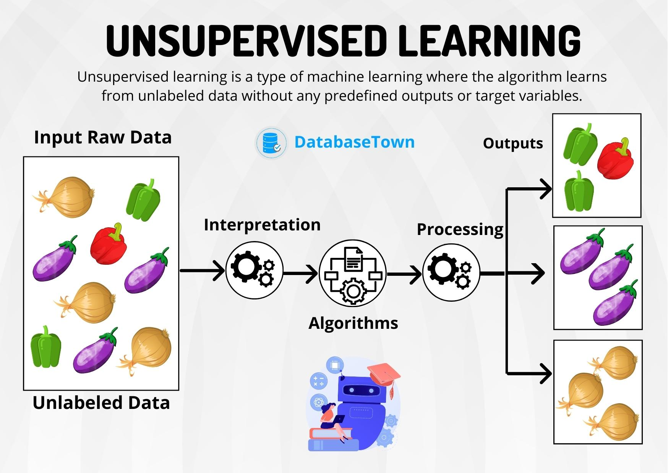

On what basis is this similarity understood?

What is Unsupervised Learning?
Unsupervised learning is a branch of machine learning where the model learns patterns from unlabeled data—i.e., there are no output labels or targets provided. The goal is to identify hidden structures or groupings in the data.
Common tasks:
- Clustering
- Dimensionality Reduction
- Anomaly Detection
- Association Rule Mining
=================================
Unsupervised learning is where the model learns patterns and structures from data without labeled outputs.
The goal is often clustering, dimensionality reduction, or association rule learning.
Unsupervised learning is a type of machine learning where algorithms learn from unlabeled data, discovering hidden patterns and structures without explicit guidance. Unlike supervised learning, it doesn't rely on labeled examples or correct answers to guide the learning process. Instead, it explores the data to identify inherent groupings, relationships, or anomalies.
Here's a more detailed explanation:
Key Characteristics:
- Unlabeled Data:
The core feature of unsupervised learning is its use of data without pre-defined categories or labels.
- Pattern Discovery:
Algorithms aim to find hidden patterns, structures, and relationships within the data.
- No Supervision:
Unlike supervised learning, there's no external "teacher" or labeled data to correct the algorithm's outputs.
- Exploratory Analysis:
Unsupervised learning is often used for exploratory data analysis, where the goal is to gain insights and understand the data's characteristics.
- Clustering, Dimensionality Reduction, Anomaly Detection:
Common tasks in unsupervised learning include clustering (grouping similar data points), dimensionality reduction (simplifying data by reducing the number of variables), and anomaly detection (identifying unusual data points).
Examples of Unsupervised Learning Applications:
- Customer Segmentation:
Grouping customers based on purchasing behavior, demographics, or other characteristics.
- Anomaly Detection:
Identifying fraudulent transactions, network intrusions, or unusual sensor readings.
- Recommendation Systems:
Suggesting products or content based on user preferences and browsing history.
- Dimensionality Reduction:
Reducing the number of features in a dataset while preserving important information.
- Image and Video Analysis:
Discovering patterns and structures in visual data.
In essence, unsupervised learning is a powerful tool for exploring data, uncovering hidden structures, and gaining insights that might not be apparent through other methods.
Advantages of Unsupervised Learning:
- No need for labeled data:
This eliminates the costly and time-consuming process of manually labeling data, making it suitable for scenarios where labeled data is scarce or unavailable.
- Exploratory analysis:
Unsupervised learning can uncover hidden patterns and relationships within data, providing valuable insights for further analysis and decision-making.
- Flexibility and adaptability:
It can handle diverse and dynamic datasets without requiring predefined structures, making it adaptable to various data types and scenarios.
- Scalability:
Unsupervised learning algorithms can efficiently process large datasets, making it suitable for handling big data applications.
- Discovery of hidden patterns:
It can identify natural groupings, anomalies, and relationships within data that might not be apparent through other methods.
- Cost-effective:
By requiring less manual intervention, unsupervised learning can be more cost-effective than supervised learning in some cases.
- Useful for complex tasks:
It is particularly useful for complex tasks like grouping large datasets into clusters.
Disadvantages of Unsupervised Learning:
- Lack of precision in outcome interpretation:
Without labeled data, it can be difficult to determine the accuracy and relevance of the identified patterns.
- Difficulty in evaluating model performance:
It can be challenging to measure the performance of unsupervised models as there are no predefined target variables for comparison.
- Human intervention required:
Often, human interpretation and validation are needed to correlate the discovered patterns with domain knowledge.
- Potential for inaccurate results:
The absence of labeled data can lead to less accurate results, especially if the data contains noise or outliers.
- Longer processing time:
Processing time can be longer as the model needs to explore all possibilities without prior knowledge.
- Sensitivity to noise and outliers:
The results can be misleading if the data contains noise or outliers.
- Requires more complex programming:
It often requires more complex programming knowledge and skills to work with unclassified information.
=================================
Common Types of Models and Applications:
======================================================
1. Clustering: This involves grouping similar data points together based on inherent characteristics within the data. Examples include:
Groups similar data points together, like grouping customers based on purchasing behavior or identifying customer segments.
  - Example: K-means clustering is a popular algorithm for this task.
- K-Means Clustering:
Partitions data into k clusters based on proximity to cluster centroids.
- Hierarchical Clustering:
Creates a tree-like structure of clusters, allowing for analysis at various levels of granularity.
- Gaussian Mixture Models:
Uses probability distributions to assign data points to clusters, allowing for soft clustering (a data point can belong to multiple clusters with varying probabilities).
- DBSCAN:
Clusters data points based on density, identifying core points, border points, and outliers.
2. Association Rule Learning: This aims to discover relationships and dependencies between variables in a dataset. A common example is:
Discovers relationships and patterns between variables in large datasets, like finding products that are frequently purchased together.

- Apriori Algorithm: Used to find frequent itemsets and association rules in transactional data.
3. Dimensionality Reduction: This technique reduces the number of variables in a dataset while retaining important information. Examples include:
Reduces the number of variables in a dataset while preserving important information, often used for data visualization and noise reduction.
  - Example: Principal Component Analysis (PCA) is a widely used technique.
- Principal Component Analysis (PCA):
Transforms data into a new coordinate system, prioritizing the directions of highest variance.
- Singular Value Decomposition (SVD):
A matrix factorization technique used for dimensionality reduction and other tasks.
- t-distributed Stochastic Neighbor Embedding (t-SNE):
A non-linear dimensionality reduction technique particularly useful for visualizing high-dimensional data.
- 4. Anomaly Detection:
Identifies data points that deviate significantly from the norm, useful for fraud detection or identifying system errors.
- 5. Autoencoders:
Neural networks that learn to compress and reconstruct data, often used for dimensionality reduction and feature learning.
- 6. Generative AI:
Models that learn the underlying probability distribution of the data to generate new, similar data points.
- Audience Segmentation:
Identifying distinct groups of users based on their behavior and characteristics.

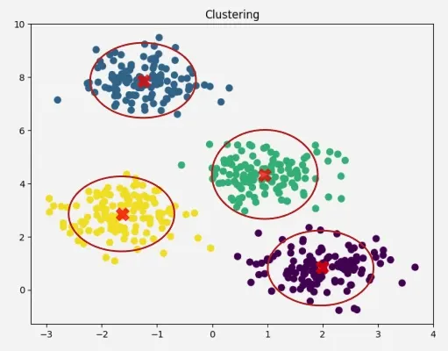

✅ 1. K-Means Clustering

📘 Definition:
K-Means partitions data into k clusters by minimizing the variance within each cluster.

🧠 Intuition:
It assigns data points to clusters based on nearest centroid.

🧪 Code:
from sklearn.cluster import KMeans
from sklearn.datasets import make_blobs
import matplotlib.pyplot as plt

X, _ = make_blobs(n_samples=300, centers=3, cluster_std=0.6)
kmeans = KMeans(n_clusters=3)
kmeans.fit(X)
plt.scatter(X[:, 0], X[:, 1], c=kmeans.labels_)
plt.scatter(kmeans.cluster_centers_[:, 0], kmeans.cluster_centers_[:, 1], s=100, c='red')
plt.show()

✅ Advantages:
- Simple and fast
- Easy to implement
- Works well with spherical clusters

❌ Disadvantages:
- Need to specify k
- Sensitive to initialization
- Poor with non-convex shapes

📈 Use Case:
Customer segmentation, document clustering

📍 When to Use:
Data naturally forms clusters & k is approximately known

🚧 Limitation:
- Not good with different density clusters
🔁 Alternative: DBSCAN

✅ 2. DBSCAN (Density-Based Spatial Clustering)

📘 Definition:
Groups points closely packed together and labels outliers as noise.

🧠 Intuition:
Clusters based on density of points rather than shapes or centroids.

🧪 Code:
from sklearn.cluster import DBSCAN

db = DBSCAN(eps=0.3, min_samples=5)
db.fit(X)
plt.scatter(X[:, 0], X[:, 1], c=db.labels_)
plt.show()

✅ Advantages:
- No need to specify clusters
- Detects outliers
- Works well with irregular shapes

❌ Disadvantages:
- Sensitive to eps and min_samples
- Not great with varying densities

📈 Use Case:
Anomaly detection, geospatial analysis

📍 When to Use:
When clusters are of arbitrary shapes or noise needs detection

🚧 Limitation:
- Struggles with high dimensions
🔁 Alternative: HDBSCAN, PCA before DBSCAN

✅ 3. Hierarchical Clustering (Agglomerative)

📘 Definition:
Builds a hierarchy of clusters using either top-down (divisive) or bottom-up (agglomerative) approach.

🧠 Intuition:
Creates a dendrogram to visualize the hierarchy of clusters.

🧪 Code:
from sklearn.cluster import AgglomerativeClustering
import scipy.cluster.hierarchy as sch

plt.figure()
dendrogram = sch.dendrogram(sch.linkage(X, method='ward'))
plt.show()

hc = AgglomerativeClustering(n_clusters=3)
labels = hc.fit_predict(X)
plt.scatter(X[:, 0], X[:, 1], c=labels)
plt.show()

✅ Advantages:
- Visual interpretation (dendrogram)
- No need to specify k initially

❌ Disadvantages:
- Slow for large datasets
- Sensitive to noise

📈 Use Case:
Gene expression data, taxonomy, social network analysis

📍 When to Use:
Need to visualize how clusters form at various levels

✅ 4. PCA (Principal Component Analysis)

📘 Definition:
Reduces dimensionality by projecting data onto directions of maximum variance.

🧠 Intuition:
Transforms correlated features into uncorrelated principal components.

🧪 Code:
from sklearn.decomposition import PCA

pca = PCA(n_components=2)
X_reduced = pca.fit_transform(X)
plt.scatter(X_reduced[:, 0], X_reduced[:, 1])
plt.title('PCA Projection')
plt.show()

✅ Advantages:
- Removes redundancy
- Helps with visualization and noise reduction

❌ Disadvantages:
- Linear transformation
- Hard to interpret components

📈 Use Case:
Preprocessing, compression, visualization, finance

📍 When to Use:
High-dimensional data or collinearity

🚧 Limitation:
- Not suitable for non-linear structures
🔁 Alternative: t-SNE, UMAP

✅ 5. t-SNE (t-Distributed Stochastic Neighbor Embedding)

📘 Definition:
Non-linear technique that maps high-dimensional data to 2 or 3D for visualization.

🧠 Intuition:
Preserves local structure using probabilistic similarity.

🧪 Code:
from sklearn.manifold import TSNE

tsne = TSNE(n_components=2)
X_embedded = tsne.fit_transform(X)
plt.scatter(X_embedded[:, 0], X_embedded[:, 1])
plt.title('t-SNE Projection')
plt.show()

✅ Advantages:
- Excellent for visualization
- Captures local clusters

❌ Disadvantages:
- Not scalable
- No inverse transform

📈 Use Case:
Visualizing embeddings, image data, NLP

📍 When to Use:
Only for visualization, not for prediction or transformation

🚧 Limitation:
- Slow on large datasets
🔁 Alternative: UMAP

✅ 6. Autoencoders (Deep Learning-based)

📘 Definition:
Neural networks trained to reconstruct their inputs. The middle layer acts as a compressed representation.

🧠 Intuition:
Learns efficient low-dimensional representations.

🧪 Code:
from keras.models import Model
from keras.layers import Input, Dense

input_dim = X.shape[1]
input_layer = Input(shape=(input_dim,))
encoded = Dense(10, activation='relu')(input_layer)
decoded = Dense(input_dim, activation='sigmoid')(encoded)

autoencoder = Model(input_layer, decoded)
autoencoder.compile(optimizer='adam', loss='mse')
autoencoder.fit(X, X, epochs=10, batch_size=32)

✅ Advantages:
- Learns non-linear patterns
- Useful for anomaly detection

❌ Disadvantages:
- Requires tuning
- Needs more data

📈 Use Case:
Dimensionality reduction, denoising, fraud detection

📍 When to Use:
When traditional methods don’t scale well or need flexibility

🔁 Summary Table
Model | Task | Shape Flexibility | Scales Well | Best For
KMeans | Clustering | ✖ (Convex only) | ✅ | Quick clustering
DBSCAN | Clustering | ✅ | ✖ | Irregular shapes, noise
Hierarchical | Clustering | ✅ | ✖ | Dendrogram & hierarchical view
PCA | Dimensionality | ✖ (Linear only) | ✅ | Compression, visualization
t-SNE | Dimensionality | ✅ | ✖ | Visualization only
Autoencoder | Dimensionality | ✅✅ | ✅ | Deep features, anomaly detection

# Unsupervised Learning with Real Dataset (Iris)

from sklearn.datasets import load_iris
from sklearn.preprocessing import StandardScaler
from sklearn.decomposition import PCA
from sklearn.cluster import KMeans, DBSCAN, AgglomerativeClustering
from sklearn.metrics import silhouette_score
import matplotlib.pyplot as plt
import seaborn as sns
import pandas as pd

# Load the dataset
iris = load_iris()
X = iris.data
y = iris.target

# Standardize the features
scaler = StandardScaler()
X_scaled = scaler.fit_transform(X)

# PCA for 2D projection
pca = PCA(n_components=2)
X_pca = pca.fit_transform(X_scaled)

# KMeans Clustering
kmeans = KMeans(n_clusters=3, random_state=42)
kmeans_labels = kmeans.fit_predict(X_scaled)
kmeans_silhouette = silhouette_score(X_scaled, kmeans_labels)

# DBSCAN Clustering
dbscan = DBSCAN(eps=0.5, min_samples=5)
dbscan_labels = dbscan.fit_predict(X_scaled)
dbscan_silhouette = silhouette_score(X_scaled, dbscan_labels) if len(set(dbscan_labels)) > 1 else -1

# Agglomerative Clustering
agglo = AgglomerativeClustering(n_clusters=3)
agglo_labels = agglo.fit_predict(X_scaled)
agglo_silhouette = silhouette_score(X_scaled, agglo_labels)

# Plot Clusters on PCA projection
fig, axs = plt.subplots(1, 3, figsize=(18, 5))
axs[0].scatter(X_pca[:, 0], X_pca[:, 1], c=kmeans_labels, cmap='viridis')
axs[0].set_title(f"KMeans (Silhouette = {kmeans_silhouette:.2f})")

axs[1].scatter(X_pca[:, 0], X_pca[:, 1], c=dbscan_labels, cmap='viridis')
axs[1].set_title(f"DBSCAN (Silhouette = {dbscan_silhouette:.2f})")

axs[2].scatter(X_pca[:, 0], X_pca[:, 1], c=agglo_labels, cmap='viridis')
axs[2].set_title(f"Agglomerative (Silhouette = {agglo_silhouette:.2f})")

plt.suptitle("Unsupervised Learning Clustering Results on Iris Dataset", fontsize=16)
plt.tight_layout()
plt.show()

# Print evaluation summary
print("\nSilhouette Scores:")
print(f"KMeans: {kmeans_silhouette:.4f}")
print(f"DBSCAN: {dbscan_silhouette:.4f}")
print(f"Agglomerative: {agglo_silhouette:.4f}")

Add models like Autoencoders, t-SNE, or UMAP? AND FINE TUNE STEPS

# Unsupervised Learning with Real Dataset (Iris) + Autoencoders, t-SNE, UMAP, and Fine-Tuning

"""
🧠 Unsupervised Learning Summary Notes
--------------------------------------
1. Goal: Discover hidden patterns/structures in unlabeled data.

2. Key Techniques:
- Clustering: KMeans, DBSCAN, Agglomerative Clustering
- Dimensionality Reduction: PCA, t-SNE, UMAP, Autoencoders

3. When to Use:
- No labeled output
- Need to reduce high-dimensional data
- Segmenting data into groups (e.g., customer segmentation)

4. Evaluation Techniques:
- Silhouette Score (0 to 1, higher is better)
- Visual inspection with PCA/t-SNE/UMAP
- Cluster purity (if labels are known)

5. Tips:
- Always scale/normalize features before clustering
- Try multiple clustering methods
- Use dimensionality reduction for visualization
- Fine-tune hyperparameters like eps (DBSCAN), k (KMeans)

6. Limitations & Remedies:
- Clusters may not reflect meaningful structure → Combine with domain knowledge
- DBSCAN fails on varying densities → Try HDBSCAN
- PCA is linear → Use t-SNE or UMAP for nonlinear cases
- Autoencoders need sufficient data and tuning → Regularization helps

7. Popular Applications:
- Market segmentation
- Anomaly detection
- Image compression
- Gene expression analysis
- Recommendation engines

"""

from sklearn.datasets import load_iris
from sklearn.preprocessing import StandardScaler
from sklearn.decomposition import PCA
from sklearn.cluster import KMeans, DBSCAN, AgglomerativeClustering
from sklearn.metrics import silhouette_score
from sklearn.manifold import TSNE
import umap.umap_ as umap
from tensorflow.keras.models import Model
from tensorflow.keras.layers import Input, Dense
from tensorflow.keras.optimizers import Adam
import matplotlib.pyplot as plt
import seaborn as sns
import pandas as pd
import numpy as np

# Load and scale data
iris = load_iris()
X = iris.data
y = iris.target
scaler = StandardScaler()
X_scaled = scaler.fit_transform(X)

# PCA for projection
pca = PCA(n_components=2)
X_pca = pca.fit_transform(X_scaled)

# t-SNE projection
tsne = TSNE(n_components=2, perplexity=30, random_state=42)
X_tsne = tsne.fit_transform(X_scaled)

# UMAP projection
umap_model = umap.UMAP(n_components=2, random_state=42)
X_umap = umap_model.fit_transform(X_scaled)

# Autoencoder for dimensionality reduction
input_dim = X_scaled.shape[1]
input_layer = Input(shape=(input_dim,))
encoded = Dense(4, activation='relu')(input_layer)
encoded = Dense(2, activation='relu')(encoded)
decoded = Dense(4, activation='relu')(encoded)
decoded = Dense(input_dim, activation='linear')(decoded)

autoencoder = Model(inputs=input_layer, outputs=decoded)
autoencoder.compile(optimizer=Adam(learning_rate=0.01), loss='mse')
autoencoder.fit(X_scaled, X_scaled, epochs=100, batch_size=16, verbose=0)

# Use encoder part
encoder = Model(inputs=input_layer, outputs=encoded)
X_encoded = encoder.predict(X_scaled)

# Clustering Algorithms
kmeans = KMeans(n_clusters=3, random_state=42)
kmeans_labels = kmeans.fit_predict(X_scaled)
kmeans_sil = silhouette_score(X_scaled, kmeans_labels)

dbscan = DBSCAN(eps=0.5, min_samples=5)
dbscan_labels = dbscan.fit_predict(X_scaled)
dbscan_sil = silhouette_score(X_scaled, dbscan_labels) if len(set(dbscan_labels)) > 1 else -1

agglo = AgglomerativeClustering(n_clusters=3)
agglo_labels = agglo.fit_predict(X_scaled)
agglo_sil = silhouette_score(X_scaled, agglo_labels)

# Visualization
fig, axs = plt.subplots(2, 3, figsize=(18, 10))
axs[0, 0].scatter(X_pca[:, 0], X_pca[:, 1], c=kmeans_labels)
axs[0, 0].set_title("KMeans (PCA)")

axs[0, 1].scatter(X_tsne[:, 0], X_tsne[:, 1], c=kmeans_labels)
axs[0, 1].set_title("KMeans (t-SNE)")

axs[0, 2].scatter(X_umap[:, 0], X_umap[:, 1], c=kmeans_labels)
axs[0, 2].set_title("KMeans (UMAP)")

axs[1, 0].scatter(X_encoded[:, 0], X_encoded[:, 1], c=kmeans_labels)
axs[1, 0].set_title("KMeans (Autoencoder)")

axs[1, 1].scatter(X_pca[:, 0], X_pca[:, 1], c=dbscan_labels)
axs[1, 1].set_title("DBSCAN (PCA)")

axs[1, 2].scatter(X_pca[:, 0], X_pca[:, 1], c=agglo_labels)
axs[1, 2].set_title("Agglomerative (PCA)")

plt.tight_layout()
plt.show()

# Summary of results
print("\nSilhouette Scores:")
print(f"KMeans: {kmeans_sil:.4f}")
print(f"DBSCAN: {dbscan_sil:.4f}")
print(f"Agglomerative: {agglo_sil:.4f}")

# Fine-tuning Example for DBSCAN
print("\nDBSCAN Fine-Tuning:")
best_score = -1
best_params = (0, 0)
for eps in [0.3, 0.5, 0.7]:
for min_samples in [3, 5, 10]:
labels = DBSCAN(eps=eps, min_samples=min_samples).fit_predict(X_scaled)
if len(set(labels)) > 1:
score = silhouette_score(X_scaled, labels)
print(f"eps={eps}, min_samples={min_samples} => Silhouette={score:.4f}")
if score > best_score:
best_score = score
best_params = (eps, min_samples)

print(f"Best DBSCAN Parameters: eps={best_params[0]}, min_samples={best_params[1]} with Silhouette={best_score:.4f}")

